

**FaZe Clan : Visit and Vote Your Player**

**Group 1**

Names : Anugrah Perdana

Arfandra Rezky

Bunga Kulsum Veriena

Class : 2SC1

Faculty : Emma Yulianti, ST, MM.

**FAKULTAS TEKNIK UNIVERSITAS INDONESIA**

**2019**

**PREFACE**

Thank to Almalthy God who has given His bless to us for finishing this Project. Hope the author, hopefully this time the papers can be beneficial to the readers, so that they can increase their knowledge and insight. In the completion of the preparation of this paper writer also realize that there are still many shortcomings. Therefore, criticisms and suggestions that writer expect as input for the next paper. And writer also hope this paper could be useful for anyone who read it.

The author also realize this project has many shortcomings and errors in it, hopefully this lack can be an evaluation material for the next generation to be better. The author also expects the reader's openness to criticize and give suggestions for further better writing. Hopefully, this paper can help the readers to expand their knowledge.

|  |
| --- |
| Depok, July 2019 |
|  |
| Author |

2

**PROJECT ON**

*FaZe Clan : Visit and Vote Your Player*

**Developed by**

1. **Anugrah Perdana**
2. **Arfandra Rezky**
3. **Bunga Kulsum Veriena**



3

**PROJECT ON**

*FaZe Clan : Visit and Vote Your Player*

Batch Code : 2SC1

Start Date : 17 June 2019   
End Date : 4 July 2019

Name of Faculty : Emma Yulianti

Names of Developer :

1. Anugrah Perdana
2. Arfandra Rezky
3. Bunga Kulsum Veriena

Date of Submission: 5 July 2019

4



**CERTIFICATE**

This is to ensure that the report of HTML to create website of **FaZe Clan : Visit and Vote Your Player** embodies the original work undertaken by Anugrah Perdana, Arfandra Rezky and Bunga Kulsum Veriena, in fulfillment of some of their course requirements at NIIT

Coordinator:

Ms. Emma Yulianti

**NIIT**

5

6

Author got benefited a lot from the feedback and suggestions given to us by **Ms. Emma Yulianti** and other faculty members. Author make this project to fulfill our assignment.

Author said Thanks to Allah for the blessed, so that Author can complete this project. This paper is far from perfection, for that Author ask for forgiveness from who read this paper and also can give any suggestion to make this paper better than before.

Depok, July 5th 2019

**ACKNOWLEDGEMENT**

7

**System Summary :** This website contained the information as a organization e-sport and contributes to vote the best players of FaZe Clan.

**System Process :** This website is created to knowing the informations of FaZe Clan, such as social media, team member at each game, memories of winning match, the schedule of match will be held, and contact to connect or send message to the team.

FaZe Clan popular at gamers because they have many achievements at big match around the world, such as at game COD(Call of Duty), Counter Strikes: Global Offensive, PlayerUnknown’s Battlegrounds, Tom Clancy’s Rainbow Six Siege, Fortnite Battle Royale and FIFA.

This organization improve a lot because of being winner at many match around the world. For appreciation the player, FaZe Clan makes a voting system to choose the best player that involving the fans.

.

6

**SYSTEM ANALYS***2.8*

**HARDWARE AND SOFTWARE REQUIREMENTS**

**Hardware :** PC compatible with an intel core i3 processor, 2GB RAM and 500GB of hard disk

**Operating System :** MicrosoftWindows 10

**Software :**

* NetBeans IDE 8.2
* Microsoft SQL Server Management Studio 2012
* Google Chrome

7

8

**INDIVIDUAL PROJECT SCHEDULE**

|  |  |  |  |  |  |
| --- | --- | --- | --- | --- | --- |
| S.No | Activity Description | Planned Date of Completion | Actual Date | Responsibility | Remarks |
| 1 | Analyze the case study. | 20th June 2019 | 24th June 2019 | Afrandra, Anugrah, Bunga |  |
| 2 | Design the Website. | 24th June 2019 | 25th June 2019 | Afrandra, Anugrah |  |
| 3 | Create Web pages. | 25th June 2019 | 26th June 2019 | Afrandra, Anugrah, |  |
| 4 | Create JavaScript forms and perform validations. | 26th June 2019 | 29th June 2019 | Afrandra, Anugrah, |  |
| 5 | Add content, meta keywords, and description to the Web pages. | 1th July 2019 | 1th July 2019 | Afrandra, Anugrah, Bunga |  |
| 6 | Document the project by using the formats given in the later section. | 2th July 2019 | 3th July 2019 | Afrandra, Anugrah, Bunga |  |

9

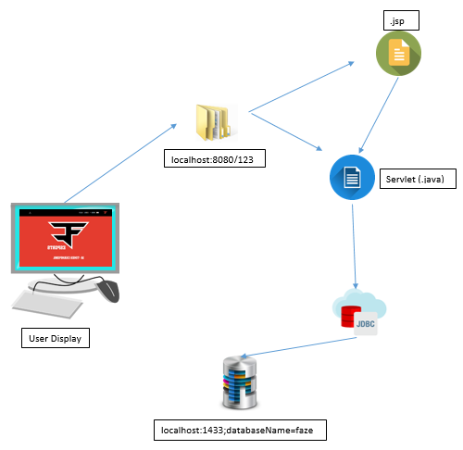

**TECHNOLOGY DIAGRAM**

10

**TECHNOLOGY DIAGRAM**



Type data of .jsp at this project





Controller





11

**TECHNOLOGY DIAGRAM**

Model





Modeladmin





12

|  |  |  |
| --- | --- | --- |
| **S.No** | **File Name** | **Remarks** |
| 1 | 123 | Web, scr |
| 2 | faze |  |

**PROJECT FILE DETAILS**

13